CONFIDENTIALITY AND NON-DISCLOSURE AGREEMENT

In consideration of employment with R Systems International Ltd. (RSI), I agree as follows:

CONFIDENTIALITY OF TRADE SECRETS:

(a) I specifically agree that I shall not at any time, either during or subsequent to the term of my employment with RSI in any fashion, form or manner, either directly or indirectly, unless expressly consented to in writing by RSI’s Managing Director or required by law to do so, use, divulge, disclose or communicate to any person or entity any confidential information of any kind, nature or description concerning any matters affecting or relating to the business of RSI. This includes, but is not limited to, RSI’s computer processes, programs and codes; the names, addresses, buying habits or practices of any of its clients or customers; RSI’s marketing methods, programs and related data, LEGAL RESPONSIBLITIES & RIGHTS, COPYRIGHT LAWS OR DATA PROTECTION LEGISLATION wherever applicable or other written records used in RSI’s business.

In addition to the above information, also included in this category is compensation paid to other employees and independent contractors and other terms of their employment or contractual relationships; or any other confidential information of, about or concerning the business of RSI, its manner of operations, or other data of any kind, nature or description. The parties to this Agreement hereby stipulate that, as between them, the above information and items are important, material and confidential trade secrets that affect the successful conduct of RSI’s business and its goodwill, and that any breach of any term of this section is a material breach of this Agreement.

All equipment, notebooks, documents, memoranda, reports, files, samples, books, correspondence, lists or other written and graphic records, and the like, including tangible or intangible computer programs, records and data, affecting or relating to the business or RSI, which I might prepare, use, construct, observe, possess or control, shall be and shall remain RSI’s sole property.

(b) I agree that all business procured by me while employed by RSI INCLUDING PERSONAL INFORMATION RECEIVED OR CREATED AS A RESULT OF, OR IN THE COURSE OF, EMPLOYMENT is and shall remain the permanent and exclusive property of RSI.

(c) Any interference with RSI’s business, property, confidential information, trade secrets, clients, customers, employees or independent contractors by me or any of RSI’s agents during or after the term of my employment shall be treated and acknowledged by the parties as a material breach of this Agreement.

I agree that i am responsible for all actions taken by me, it also covers any official assignment extended outside the organization’s premises and outside normal working hours

NON-SOLICITATION

I hereby acknowledge and agree that I will likely be exposed to a significant amount of confidential information concerning RSI’s business methods, operations and customers while employed by RSI, that such information might be retained by me in tangible form or simply retained in my memory, and that the

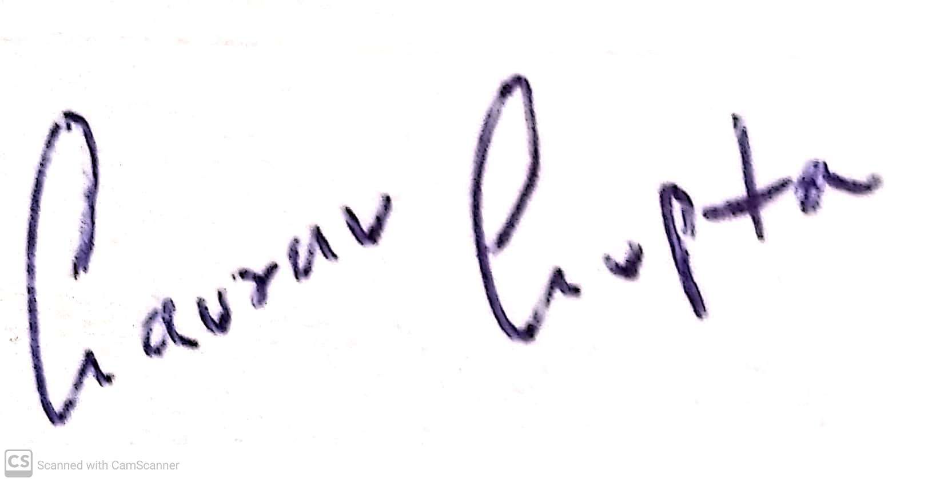

Signature of Employee Authorized Signatory
Employee Name: Gaurav Gupta
Employee code: 15476
Date : 07-11-2022
protection of RSI’s exclusive rights to such confidential information and trade secrets can best be ensured by means of a restriction on my activities after termination of employment. Therefore, the parties agree that for a one-year period following employment termination (whether voluntary or involuntary and with or without cause)I shall not solicit, divert or initiate any contact with (or attempt to solicit, divert or initiate any contact with) any customer, client, independent contractor or employee of RSI for any commercial or business reason whatsoever.

CONDUCT
Prior and subsequent to your termination date, if any, you shall not or attempt to in any manner: (i) interfere with any of RSI’s business; (ii) interfere in any manner with any of RSI’s employees or independent contractors; (iii) use any of RSI’s trade secrets, including but not limited to its customer lists, or other property, except in the best interests of the RSI; or (iv) withhold any premiums, deposits or other forms of payments, applications, financial or confidential information of the RSI’s clients or customers.

INJUNCTIVE RELIEF
I hereby acknowledge and agree that any violation of this Agreement pertaining to Trade Secrets, Non-Solicitation, and Conduct will cause damage to RSI in an amount difficult to ascertain. Accordingly, in addition to any other relief to which RSI may be entitled, the parties agree that RSI shall be entitled to temporary or permanent injunctive relief for any breach or threatened breach by the Employee of the terms of this Agreement without proof of actual damages that have been or may be caused to RSI as a result of such breach.

GOVERNING LAW
That the jurisdiction of Courts in Delhi shall only apply to any dispute arising out of this appointment letter.

SEVERABILITY
In the event that any covenant, condition or other provision of this Agreement is held to be inoperative, invalid, void or illegal by any court of competent jurisdiction, the same shall be deemed severable from the remainder of this Agreement and shall in no way affect, impair or invalidate any other covenant, condition or other provision of this Agreement. If such condition, covenant or other provision shall be deemed invalid due to its scope or breadth, such covenant, condition or other provision shall be deemed valid to the extent of the scope or breadth permitted by law.

ENTIRE AGREEMENT
This Agreement sets forth the entire agreement between the parties with respect to this subject matter. All agreements, covenants, representations or warranties, express or implied, of the parties with regard to this subject matter are contained in this Agreement and in the documents referred to in or implementing their provisions. No other agreements, covenants, representations or warranties, express or implied, oral or written, have been made outside of this Agreement. All prior and contemporaneous conversations, negotiations, possible and alleged agreements and representations, covenants and warranties with respect to the subject matter are waived, merged and superseded by this Agreement.

____________________ ______________________

Signature of Employee Authorized Signatory
Employee Name: Gaurav Gupta
Employee Code: 15476
Date : 07-11-2022

